
TURVATIKAS SAFETY LADDER®

Inspection Manual

Hot-dip galvanized and acid-proof AISI 316 products

Take the next step towards Safety





Turvatikas Safety Ladder®

Finnish fall arrest system for masts and other high structures.



These inspection instructions must always be followed when inspecting Turvatikas Safety Ladder products.

The latest version of these instructions can be found at https://turvatikas.fi/en/documents-2/product-manuals-2/.

Eltel Networks Oy reserves all rights to edit this document during its period of validity.

Eltel Networks Oy
Laturinkuja 8
02650 Espoo
FINLAND
Tel. +358 20 411 211
turvatikas@eltelnetworks.com

2026

DRAFT v 0.08

TABLE OF CONTENTS

TABLE OF CONTENT 2
1. WARNINGS AND CONSIDERATIONS 3
2. SIGNAGE 4
3. SAFETY RAIL MARKINGS 5
4. INSPECTION INSTRUCTIONS FOR THE SYSTEM 6
5. INSPECTION REPORT 8
6. TECHNICAL DATA SHEET 9

WARNINGS AND CONSIDERATIONS
Only a Turvatikas Safety Ladder® inspector authorized by Eltel Networks Oy and holding a valid Turvatikas Safety Ladder® inspector’s certificate is permitted to perform inspections of the Turvatikas Safety Ladder® Fall Arrest System.
Eltel Networks Oy provides the products required for inspecting the Turvatikas Safety Ladder® Fall Arrest System free of charge. The delivery address for these products can be sent by email to turvatikas@eltelnetworks.com. Delivery is conditional on the inspector having a valid Turvatikas Safety Ladder® inspector’s certificate.
The Fall Arrest System must always be inspected after installation and before being taken into use, as well as regularly every 12 months. The Fall Arrest System must be taken out of use if it has not been inspected within the last 12 months, if there is reason to suspect that the system may not be safe to use for any other reason, or if the Fall Arrest System has arrested a fall.
A Fall Arrest System that has been taken out of use may not be returned to use until a Turvatikas Safety Ladder® inspector authorized by Eltel Networks Oy has confirmed in writing that the system meets all requirements and is safe to use.
The Fall Arrest System consists of several components, which must be installed and connected to each other according to the provided instructions. Incorrectly installed or connected components may pose a serious risk to safety and health.
It is forbidden to make any modifications or additions to the Fall Arrest System without a written permission from Eltel Networks Oy.
It is forbidden to replace any part of the Fall Arrest System with anything other than a component designed and manufactured by Eltel Networks Oy specifically for the Turvatikas Safety Ladder® Fall Arrest System.

NOTE!
Except for the Basic Clamp No. 15, the brackets of the Turvatikas Safety Ladder® are not included in the Turvatikas Safety Ladder® fall-arrest system. Nevertheless, their installation and fastening should be inspected during fall-arrest system inspections.

STANDARDS AND DECLARATION OF CONFORMITY

The Turvatikas Safety Ladder Climbing Carriage and Vertical Profile combination has been tested in accordance with the standard EN353-1:2014+A1:2017, test method VG11 RfU11.073 and thus complies with the requirements the EU Personal Protective Equipment Regulation 2016/425.
The type examination certificate has been issued by SGS Fimko, Takomotie 8, 00380 Helsinki, notified body 0598. SGS Fimko also supervises the production quality consistency.
The declaration of conformity of the Turvatikas Safety Ladder system can be found here:
https://turvatikas.fi/en/documents/product-certificates/

SIGNAGE
The contents and necessity of the Sign Plate has been defined in EN353-1:2014+A1:2017 and EN365:2004+AC:2006 standards, as well as the PPE Regulation.
The Sign Plate must be installed on the Fall Arrest System or in its immediate vicinity at every access point to the Fall Arrest System.

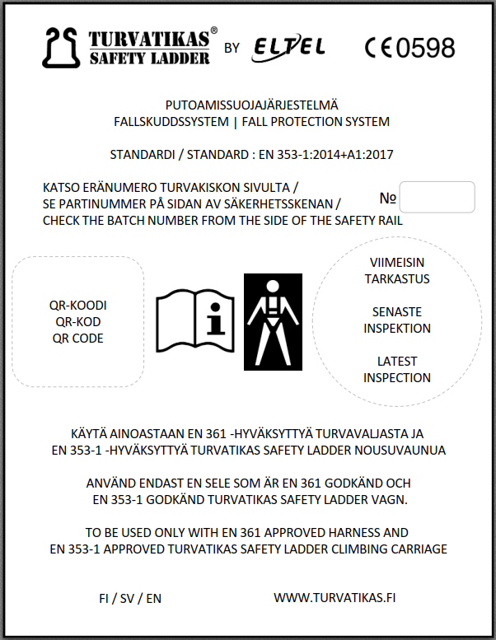

SAFETY RAIL MARKINGS
Left outer edge of the safety rail (since year 2000)
- TURVATIKAS SAFETY LADDER = Brand name.

- CE0598 = Number of the body participating in the product’s control phase (SGS Fimko).

Right outer edge of the safety rail (since year 2002)

- SFS EN 353-1:2014+A1:2017 = the standard whose requirements the safety rail meets.

- No 930 CE (and since 2017 No 931 CE, No 932 CE and No 940 CE) = the type number of the safety carriage compatible with the safety rail.

- XXX = Three-digit number stating the manufacturing year and batch ID (at a 90 degree angle to other markings).

Rear or front edge of the lowest step of the Safety Ladder (since year 2024)

- The manufacturing date of the Safety Ladder.

NOTE!
Vertical Profile may include the marking CE0403, which is the number of the body that previously participated in the product’s monitoring (Finnish Institute of Occupational Health).

NOTE!
If the inspector is uncertain about the manufacturer of the safety rail, a Turvatikas Safety Ladder® inspector or a user of the Fall Arrest System may contact Eltel Networks Oy’s Turvatikas Team to verify the manufacturer of the Vertical Profile.

Contact details can be found here: https://turvatikas.fi/en/contact-2/

MAINTENANCE AND LIFETIME
The Fall Arrest System does not have any joints or precise fits, and does not need to be oiled or greased. The Fall Arrest System lasts for decades, and there are no special requirements for their storage or maintenance. The Fall Arrest System may be used as long as it passes the inspection performed by an authorized Turvatikas Safety Ladder inspector. If there is a reason to suspect the reliability of the Fall Arrest System, its use must be prohibited until an authorized Turvatikas Safety Ladder® inspector has confirmed that the system meets all requirements and is safe to use.

INSPECTION INSTRUCTIONS FOR THE SYSTEM
Eltel Networks Oy provides the products required for inspecting the Turvatikas Safety Ladder® Fall Arrest System free of charge. The delivery address for these products can be sent by email to turvatikas@eltelnetworks.com. Delivery is conditional on the inspector having a valid Turvatikas Safety Ladder® inspector’s certificate.
The Fall Arrest System must always be inspected after installation, before being taken into use, before each use at least visually, as well as regularly every 12 months. The Fall Arrest System must be taken out of use if it has not been inspected within the last 12 months, if there is reason to suspect that the system may not be safe to use for any other reason, or if the Fall Arrest System has arrested a fall.
A Fall Arrest System that has been taken out of use may not be returned to use until a Turvatikas Safety Ladder® inspector authorized by Eltel Networks Oy has confirmed in writing that the system meets all requirements and is safe to use.
Only a Turvatikas Safety Ladder® inspector authorized by Eltel Networks Oy and holding a valid Turvatikas Safety Ladder® inspector’s certificate is permitted to perform inspections of the Turvatikas Safety Ladder® Fall Arrest System.
Since the inspection of the Fall Arrest System can be performed while climbing, e.g. an installer holding a valid Turvatikas Safety Ladder® inspector’s certificate may perform the inspection while climbing the ladder to carry out work at the top. A written inspection report must be prepared and properly stored and an inspection sticker featuring the date of inspection must be placed to the Sign Plate.
A written report must be prepared for any observed defects or deficiencies to the owner of the Fall Arrest System and/or the occupational health and safety organization of the facility or company in question, and the Fall Arrest System must be taken out of service. The observed defects and deficiencies must be fixed, after which a new inspection for the Fall Arrest System must be carried out before taking the system into use again.
An inspection report must always be prepared and stored by the owner of the Fall Arrest System. An inspection sticker indicating the inspection date must be placed to the Sign Plate located in the immediate vicinity of the Fall Arrest System.

The inspection is performed according to the following checklist:

- The previous inspection report is available.
- The markings on the safety ladder system are readable (see chapter 4)
- A Sign Plate is installed, readable, and features an inspection sticker indicating the latest inspection date.
- The sleeve joints connecting the Vertical Profiles are intact and properly tightened.
- The distance between the Vertical Profiles is max 8 mm.
- There is no projection, torsion, or other discontinuities between the Vertical Profiles.
- Bolts and nuts are tightened to the required tension, the welded seams are unbroken, and there is no significant corrosion damage.
  - M12 bolts max. 85 Nm.
  - M12 threaded rods max. 50 Nm.
  - M10 bolts max. 50 Nm.
- The safety products connected to the Vertical Profile are properly installed, intact, and function correctly and reliably.
- During the test climb, it must be ensured that:
  - The opening of the vertical profile must not exceed 17 mm.
  - Vertical Profile or Safety Ladder is secure, and it does not wobble or clatter.
  - Climbing Carriage moves across the entire length of the Vertical Profile, including through joints, openings, releasable carriage stoppers, carriage guides and bends.
- All the fasteners used in the Vertical Profile or Safety Ladder are intact and in place, and their bolts are tightened to the required tension.
- The other components of the Fall Arrest System are intact, the welded seams are unbroken, and there is no significant corrosion damage.

INSPECTION REPORT
INFORMATION ON THE SAFETY RAIL OR SAFETY LADDER INSPECTED
MODEL | TYPE | PRODUCT BATCH ID
YEAR OF MANUFACTURE | DATE OF PURCHASE | COMMISSIONING DATE
MANUFACTURER  Eltel Networks Oy  Fax: +35820411211 | ADDRESS  Laturinkuja 8  02650 Espoo  FINLAND | E-MAIL / WEBSITE  turvatikas@eltelnetworks.com  safetyladder@eltelnetworks.com  www.turvatikas.fi/en

INSPECTION COMMENTS
DATE OF THE INSPECTION | COMMENTS | NAME AND SIGNATURE OF INSPECTOR | DATE OF NEXT INSPECTION

TECHNICAL DATA SHEET
PRODUCT INFORMATION | Product type | Guided type fall arrester featuring a rigid anchor line.
 | Brand name | Turvatikas Safety Ladder®
 | Provider | Eltel Networks Oy
 | CE number | 0598
 | Material | Hot-dip galvanized steel, Acid proof steel – AISI 316
 | Zink class | Mean layer thickness 55 µm
 | Zink corrosivity category | C4 (EN 12944-2 and EN ISO 14713-1)
 | Applications | High structures, horizontal levels and pre-existing ladders
 | Compatibility | All Turvatikas Safety Ladder® components
 | Stopper tooth distance | 150 mm
 | Steel material | S355MC/JJA EN 10149-2:2013
 | Delivery lengths | 3 m (all products) ja 6 m (Vertical Profile B)
 | Warranty period | 36 months
 | Country of origin | Finland
PRODUCT CERTIFICATES | Fall protection | EN353-1:2014+A1:2017
 |  | EN 795:2012
 | Fixed ladder with fall protection system | DIN 18799-2:2019-06 (TBA-II, PTBM, PTBJ, PTBK)
PRODUCTION CERTIFICATES | Quality | ISO9001
 | Responsibility | ISO14001, EPD
 | Cerification of steel structures | EN1090-1:2009+A1:2011
 | Galvanization standard | EN ISO 1461

Turvatikas Safety Ladder®

Finnish fall arrest system for masts and other high structures.

Eltel Networks Oy

Laturinkuja 8
02650 Espoo
FINLAND

+358 20 411 211

turvatikas@eltelnetworks.com
safetyladder@eltelnetworks.com

